**GE/Soarian ADT Requirements**

**Version 1.2**

**Prepared By: Art Schwartz**

**Date: 12/12/2018**

Document Control 3

Resources 3

Project Distribution List 3

Document Version Control 3

1.1 Purpose 4

1.2 Project Scope 4

1.3 Terminology Standards 4

1.4 Document References 4

*2.* Diagram 5

3. Requirements 6

3.1 Functional Requirements 6

3.2 Non-Functional Requirements 6

3.3 Messaging Protocols 7

3.3.1 Inbound to the BayCare Cloverleaf 7

3.3.2 Outbound from the BayCare Cloverleaf 7

4. HL7 Messaging 7

4.1 Messaging Format 7

4.1.1 Segments 7

4.1*.*2 Messaging Event Types 8

4.1*.*3 Cloverleaf Configuration Files 8

4.1.4 Cloverleaf Site Location 8

4.2 Data Transformation Requirements 8

4.2.1 Soarian to GE Centicity Business 8

4.2.2 GE Centiricty Business to Soarian 10

4.3 Sample Message 14

4.3.1 From GE Centricity Business to Soarian 14

4.3.1 From Soarian to GE Centricity Business 14

5. Deployment / Implementation Model 15

# **Document Control**

## Resources

|  |  |  |
| --- | --- | --- |
| **Name** | **Role** | **Email** |
| Reginah Musyoki-Howell | PM | [Reginah.Musyoki-Howell@baycare.org](mailto:Reginah.Musyoki-Howell@baycare.org) |
| Pattie Cone | CBO MANAGEMENT SUPPORT | [Patricia.Cone@baycare.org](mailto:Patricia.Cone@baycare.org) |
| Kim Esquival | MANAGER, IS PHYSICIAN SYS-EPM | [Kimberley.Esquivel@baycare.org](mailto:Kimberley.Esquivel@baycare.org) |
| Cheri Krampert | BayCare IS Manager: Health Information Exchange | [Cheryl.Krampert@baycare.org](mailto:Cheryl.Krampert@baycare.org) |
| Peter Held | APPS PHYS PRACT SYSTEM | |  |  | | --- | --- | |  | [Peter.Held@baycare.org](mailto:Peter.Held@baycare.org) | |
| Chris Kelleher | Vendor technical Support | [chris.kelleher@ge.com](mailto:chris.kelleher@ge.com) |
| Jamey Tuma | Vendor technical Support | [jamey.tuma@ge.com](mailto:jamey.tuma@ge.com) |
|  |  |  |
|  |  |  |
|  |  |  |
|  |  |  |
|  |  |  |
|  |  |  |
|  |  |  |

## Project Distribution List

N/A

## Document Version Control

|  |  |  |  |
| --- | --- | --- | --- |
| **Version** | **Date** | **Modifier** | **Description** |
| 1.0 | 1/4/16 | Art Schwartz | Originally created |
| 1.1 | 7/27/16 | Lois Whitley/Art Schwartz | Revised and Updated with diagram |
| 1.2 | 4/19/17 | Rich Allison | Code changes for the phone numbers |
| 1.3 | 12/12/18 | Art Schwartz/Tiffany Bohall | E-statement code added |
|  |  |  |  |
|  |  |  |  |

1. Introduction

## 1.1 Purpose

This document outlines the changes required to accommodate outbound Admission, Discharge and Transfer messages Between Soarian to GE Centricity. This is a Bi-directional ADT interface

## 1.2 Project Scope

Phase 1:Implementing a Bidirectional interface to keep the 2 systems in sycnh and pass to GE CPI for net new patients

## 1.3 Terminology Standards

## 1.4 Document References

**GE Specification:**

* GE ADT Spec - BYH GEHC Registration/VM Outbound/Inbound Interface
* Soarian ADT to GE Spec

# *2.* Diagram

**All messages changed to A28**

A01 – Admit a Patient

A04 – Register a Patient

A05 – Preadmit a Patient

A08 – Update Patient Info

A28 – Add Person Info

A31 – Update Person Info

**CPI Fetch**

**BMG BMG1**

**Reg ADT**

Rev. 7/27/16

ADT Merge

**A01, A04, A05, A08, A28,A31**

**BMG1 & Reg ADT passed**

**BMG Killed - has CPI already**

**BMG CPI BMG No CPI**

**CPI Fetch**

**A28, A31**

**CPI Fetch**

# 3. Requirements

## 3.1 Functional Requirements

Provide detail for the below functional requirements. The message transformation requirements for the components defined in this specification should be specified in section 4.2 of this document.

|  |  |  |
| --- | --- | --- |
| **Cloverleaf** |  |  |
| **Number** | **Requirement Name** | **Requirement Description** |
| FR.2015.2.11 | Soarian ADT: Race,Language and Marital Status | Using a Cloverleaf Tables to cross walk between GE and Soarian for race, language and Marital values. |
|  |  |  |
|  |  |  |

## 3.2 Non-Functional Requirements

Provide concise detail for the below non-functional requirements. The below requirements must be evaluated for every project.

|  |  |  |
| --- | --- | --- |
| **Cloverleaf** |  |  |
| **Number** | **Requirement Name** | **Requirement Description** |
| NFR.20XX.1.0 | CPI Fetch | 1. All messages to Soarian will be changed to A31 2. Messages with a CPI will have EVN-5 coded to BMG, ones without a CPI are coded BMG1. 3. Messages w/o a CPI must be sent back to BMG. This is the CPI fetch. These are changed to A28 when they are sent to BMG 4. Messages with a CPI are updates to Soarian and are filtered and do not go back to BMG. |

## 3.3 Messaging Protocols

Below are listed the details for the messaging protocols that will be leveraged for this integration.

### 3.3.1 Inbound to the BayCare Cloverleaf

* adt_ge_in
* soarf_adt_xfer_13
* soarf_adt_xfer_14

### Outbound from the BayCare Cloverleaf

**PROD** adt_ge_out

Port Number: 21210

IP Address: 198.181.235.5

**Test:** adt_soarf_out

Port Number: 10268

IP Address: 64.46.229.11

# 4. HL7 Messaging

## 4.1 Messaging Format

* Soarian ADT messages follow HL7 variant version 2.6, Soarian ADT_A01
* GE ADT messages follow HL7 variant version 2.4, BMG ADT_A01.

### 4.1.1 Segments

The segments utilized for this interface are:

**Invision and Soarian**

MSH

EVN

PID

PD1

*Message Construction Notes:*

*[Square Brackets] – Optional*

*MSH – Message Header*

*EVN – Event segment*

*PID – Patient ID segment*

### 4.1*.*2 Messaging Event Types

Below are the messages types necessary for this integration

|  |  |
| --- | --- |
| **Event Type** | **Description** |
| A28 | Add Person Info |
| A31 | Update person update |

### 4.1*.*3 Cloverleaf Configuration Files

### 4.1.4 Cloverleaf Site Location

* Test and Prod: BMG

## 

## 4.2 Data Transformation Requirements

### 4.2.1 Soarian to GE Centicity Business

| **Soarian to GE Centricity ADT Spec** |  |  |  |  | **7/15/15** |
| --- | --- | --- | --- | --- | --- |
| **Field Description** | **HL7 Field Loc.** | **Required Y/N** | **Data Type** | **Length** | **Notes** |
| Sending Application | MSH.3 | Y | HD | 180 | Hard Coding “SOARIAN” |
| Sending Facility | MSH.4 | Y | HD | 180 | Hard Coding “BAYCARE” |
| Receiving Application | MSH.5 | N | HD | 180 | Hard Coding “HNAM” |
| Message Type | MSH.9 | Y | ID | 15 | COPY |
| Processing ID | MSH.11 | Y | PT | 3 | Hard Coding “P” |
| Version ID | MSH.12 | Y | VID | 60 | Hard Coding “2.6” |
| Continuation Pointer | MSH.14 | N | ST | 180 | Null Out |
| Event Type Code | EVN.1 | N | HD | 3 | Copy |
| Recorded Date/Time | EVN.2 | N | TS | 26 | Copy |
| Operator ID | EVN.5 | N | XCN | 250 | Copy. Kill if value = BMG |
| Set ID - PID | PID.1 | Y | SI | 4 | Copy |
| Patient ID (Internal) | PID.3. | Y | CX | 250 | Copy CPI into 1st occurrence Of PID-3  Copy GE MRN into 2nd occurrence Of PID-3.    Copy SS# to PID-19 inserting dashes. |
| Patient Name: Last, First, Middle | PID.5 | Y | XPN | 48 | Copy |
| Date/Time of Birth | PID.7 | Y | NM | 26 | Copy |
| Sex | PID.8 | N | IS | 1 | Copy |
| Race | PID.10 | N | CE | 80 | Uses a table (GE_SOARF_RACE) |
| Patient Address: Street 1, Street 2, City, State, Zip, Country. | PID.11 | N | XAD | 106 | Copy |
| Phone Number - Home | PID.13 | N | XTN | 40 | Looking for only HOM or CEL phones. Find and save the preferred phone number (pref). Format the phone number. If no preferred number look for a HOM or CEL number and format the phone number.  If email is present and is not None, NONE or none it is copied to PID-11 1st subfield . “NET” is copied into 2nd subfield. “Internet” is copied into 3rd subfield |
| Primary Language | PID.15 | N | CE | 250 | Uses a table (SOARF_BMG_Lanuage |
| Marital Status | PID.16 | N | CE | 250 | Uses a table (GE_SOARF_marital_status |
| Social security Number | PID.19 | N | CX | 27 | Remove dashes and copy to occurrence of 3rd occurrence PID-3  Copy GE MRN into 3rd occurrence Of PID-3.  900001 into 4th subfield. SS into 5th subfield |
| Message profile Identifier | PID.21 | N | EI | 427 | If 5th subfield =VCD. copy |
| Sending Responsible Org | PID.22 | N | XON | 567 | COPY |
| Sending Network Address | PID.24 | N | HD | 227 | If PID-21 Not NULL COPY |
| Receiving Network Address | PID.25 | N | HD | 227 | If PID-21 Not NULL COPY |

### 4.2.2 GE Centiricty Business to Soarian

| **GE Centricity to Soarian ADT Spec** |  |  |  |  | **7/15/15** |
| --- | --- | --- | --- | --- | --- |
| **Field Description** | **HL7 Field Loc.** | **Required Y/N** | **Data Type** | **Length** | **Notes** |
| Sending Application | MSH.3 | Y | HD | 180 | Hard Coding “GE CENTRICITY” |
| Sending Facility | MSH.4 | Y | HD | 180 | Hard Coding “F0A5” |
| Receiving Application | MSH.5 | N | HD | 180 | Nulled out |
| Receiving Facility | MSH.6 | N | HD | 180 | Nulled out |
| Message Type | MSH.9 | Y | ID | 15 | Hard Coding “A31” |
| Processing ID | MSH.11 | Y | PT | 3 | Hard Coding “P” |
| Version ID | MSH.12 | Y | VID | 60 | Hard Coding “2.7” |
| Event Type Code | EVN.1 | N | HD | 3 | Copy |
| Recorded Date/Time | EVN.2 | N | TS | 26 | Copy |
| Operator ID | EVN.5 | N | XCN | 250 | BMG if CPI sent  BMG1 if no CPI |
| Set ID - PID | PID.1 | Y | SI | 4 | Copy |
| Patient ID (Internal) | PID.3 | Y | CX | 250 | Copy GE MRN into 1st occurrence Of PID-3.  2198 into 4th subfield  ZPN into 5th subfield  Copy CPI if present into 2nd occurrence of PID-3.  900000 into 4th subfield.  PN into 5th subfield |
| Patient Name: Last, First, Middle | PID.5 | Y | XPN | 48 | Copy |
| Date/Time of Birth | PID.7 | Y | NM | 26 | Copy |
| Sex | PID.8 | N | IS | 1 | Copy |
| Race | PID.10 | N | CE | 80 | Uses a table (GE_SOARF_RACE) |
| Patient Address: Street 1, Street 2, City, State, Zip, Country. | PID.11 | N | XAD | 106 | Copy |
| Phone Number - Home | PID.13 | N | XTN | 40 | Looking for only HOM or CEL phones. Format the phone number. The first number in the list is the preferred number.  If email is present and is not None, NONE or none it is copied into 1st subfield . “NET” is copied into 2nd subfield. “Internet” is copied into 3rd subfield |
| Primary Language | PID.15 | N | CE | 250 | Uses a table (SOARF_BMG_Lanuage |
| Marital Status | PID.16 | N | CE | 250 | Uses a table (GE_SOARF_marital_status |
| Social security Number | PID.19 | N | CX | 27 | Remove dashes and copy to occurrence of 3rd occurrence PID-3  Copy GE MRN into 3rd occurrence Of PID-3.  900001 into 4th subfield.  SS into 5th subfield |
| Living arrangement | PD1.2 | N | IS | 12 | Hard Coding “Others” |
| Advanced Directive Last Verified Date  (used for E-statement indicator) | PD1.22 | N |  |  | Iterate on repeating OBX segment and if OBX.3.0 =1ESTATE and OBX.3.2=LSFUSERDATAP, copy OBX.5 to PD1.22 |
| OBX Segment | OBX | N |  |  | E-statement logic - If PD1-22 is not blank An OBX segment is created. The fields below are then populated. |
| Set ID | OBX-1 | N |  |  | Hard code “1” |
| Value Type | OBX-2 | N |  |  | Hard code “CE” |
| Obervation identifier – identifier | OBX-3.1 | N |  |  | Hard code “1ESTATE” |
| Obervation identifier – name of coding system | OBX-3.3 | N |  |  | Hard code “LSFUSERDATAP” |
| Observation value | OBX-5 | N |  |  | Copy PID-22 |
|  | OBX-11 | N |  |  | Hard code “R” |
| Obervation Result Status |  |  |  |  |  |

Race Table

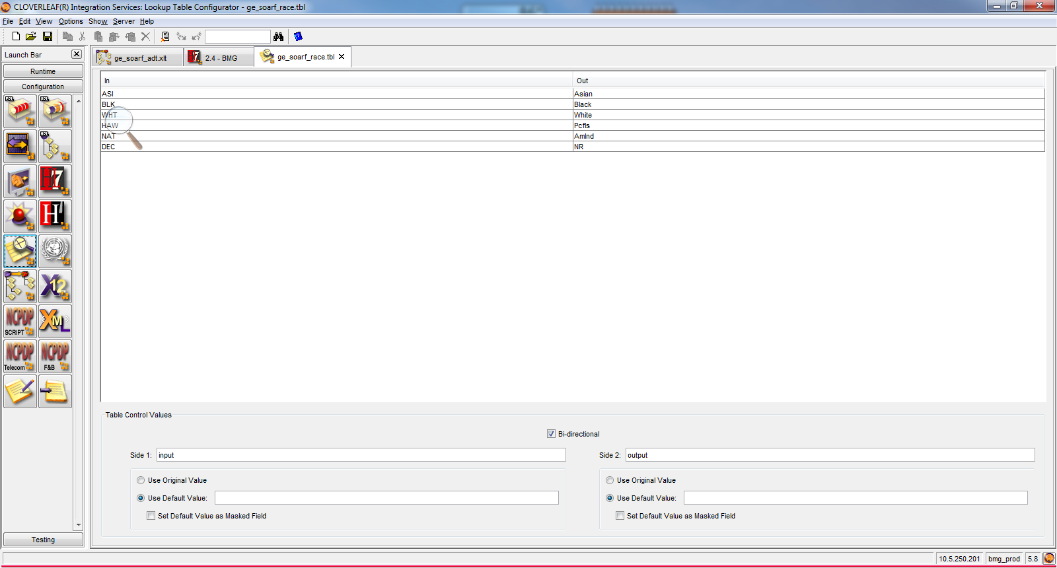

Language Table

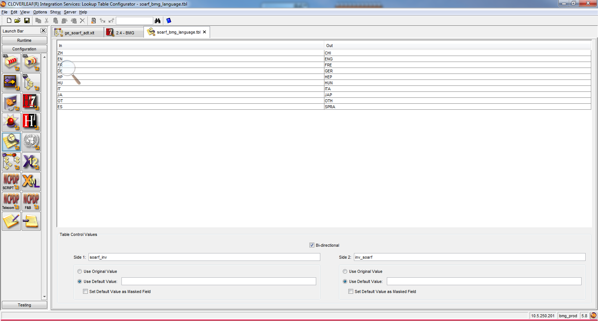

Marital Status

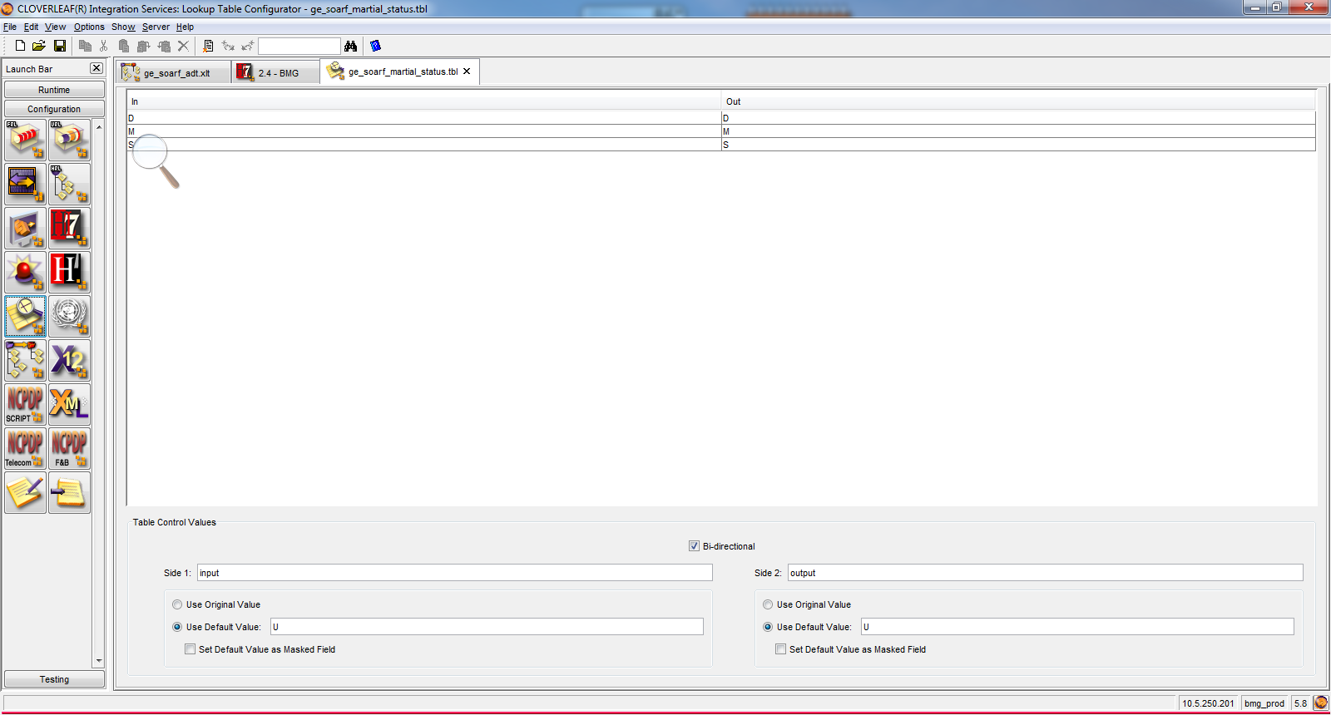

## 4.3 Sample Message

### 4.3.1 From GE Centricity Business to Soarian

**Inbound**

MSH|^~\&|BAR|IDX|HIS|HCI|201507150615||ADT^A28|63748_12_RN|P|2.3||||||ASCII|

EVN|A28|201507150615|||SIU|

PID|1||300140705^0036639^300140705||SMITH^JOSEPH^^^^||19700101|M||||||||U|||||||||||||||

PD1|||||

PV1|1|O||||||||||||||N||||||||||||||||||||||||N||||0000|0000||||||||

PV2||||||||||||||||||||||N|

GT1|1||||||||||SEL||||1||||||

ZEI|1|||||||||||

ACC|||||

ZAI|||||||||||

**Outbound**

MSH|^~\{|GE CENTRICITY|F0A5|||201507150743||ADT^A31|63748_18_IM|P|2.7

EVN|A31|201507150743|||BMG

PID|1||36220^^^2198^ZPN~300140461^^^900000^PN~888888239^^^900001^SS||MU1TESTC^UNCLE^^^^^L||19380307|M||NR|5117 SOCCER ST^^LAKELAND^FL^33809^^M|||||U

PD1||Others

### 4.3.1 From Soarian to GE Centricity Business

**Outbound**

MSH|^~\&|SOARIAN|BAYCARE|HNAM||201812031612||ADT^A28|ecf9d49c-110b-40ca-b224-fefa1eb0f0e0|P|2.6

EVN|A28|201812031612|||b127817

PID|1||810068275||TESTTWO^TESTER^B||19991225|M||BLK|934 BEACH ST^""^Beverly Hills^CA^90210||(999)888-5555||ENG|S|No Religious Preference|||||Non HIS or LAT

PD1||||||||||||||||||||||Y

# 5. Deployment / Implementation Model

Implementation will take place via rolling go live dates per facility.

* End of document